
- 4 Megapixel CMOS Sensor
- Onvif Profile S Compliant
- 3-Axis adjustment
- 2.8-12mm Motorised Lens
- 3D Digital Noise Reduction
- Digital Wide Dynamic Range
- Power over Ethernet
- 20-30m IR LED
- True Day/Night IR Cut Filter
- H.265 / H.264 Compression
- Dual Streaming
- Micro-SD Card Slot
- Grey or White Housing
PRIME IP4-EEDI2812MG/W
External Eyeball Dome with Motorised Zoom Lens (4MP)

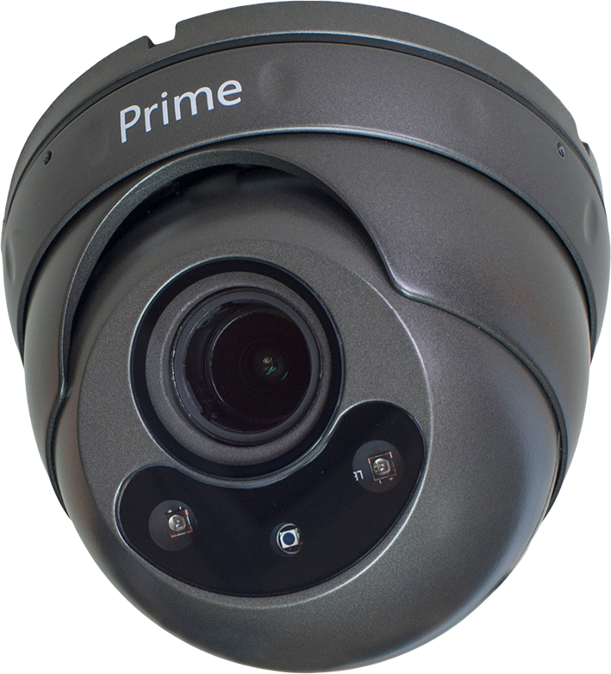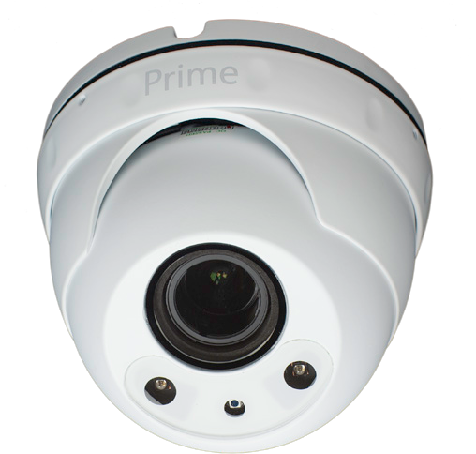Technical Specification
Hardware
Image Sensor | 1/3” Sony Exmor CMOS
Electronic Shutter | 1/25s ~ 1/10000s
Sensitivity | 0 Lux (IR On)  0.5 Lux Colour / 0.2 Lux B/W
Lens Type | 2.8 - 12mm Motorised AF Lens
Lens Interface | M12
ICR | Mechanical IR cut filter
LED | 2 Hi-Intensity IR LED  20-30m Distance (scene dependent)
Alarm I/O | No
PoE | Yes, (IEEE802.3af)
Connections | 12VDC, RJ45 Network
Power | PoE 802.3af / 12VDC 5.5W (IR Off), 7W (IR On)
Operating Temperature | -10ºC ~ 50ºC IP65 Rated
Dimensions | ø120mm x 95mm (H)
Weight | 680g

System
Video Resolution options | 2592 x 1520 @ 20pps  At 25pps: 2560 x 1440, 1080P, 720P, D1, VGA, 2CIF, CIF, QCIF
Video Adjustment options | Brightness, Contrast, Saturation, Sharpness, AGC, WDR, Mirror, 3D Noise reduction, Defog
Dual Streaming | Yes
Image Snapshot | Yes
Privacy Mask | Yes - 4 zones
Compression Format | H.265 / H.264 / MJPEG
Video Bitrate range | 16Kbps ~ 8Mbps
Onboard Storage | Micro-SD Card Slot
Video Bitrate Encoding | CBR, VBR
Motion Detection | Yes - Multi level sensitivity
OSD | Time/Date, Title
Alarm Functions | Video Loss, Network, Tampering, Motion Detection, ROI
Trigger Actions | Email, Snapshot, Zoom Preset
Security | Password
Firmware Upgrade | Yes, possible remotely via browser

Network
Ethernet | 10/100 Base-T  RJ45 cable connection
Network Protocols | TCP/IP, UDP, HTTP, DHCP, NTP, RTSP, PPPoE, DDNS, SMTP, UPNP, FTP

Acam Technology Ltd, 3 Prime Parkway, Derby DE1 3QB - www.acamtechnology.com Tel 01332 382555 - Fax 01332 382666
(Specifications subject to change without notice)

